TASK 5
d) histogram
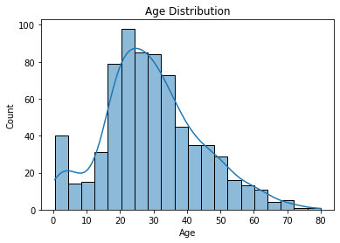
Observation
- Most passengers are aged 20–40.
- Few elderly passengers.

Boxplot
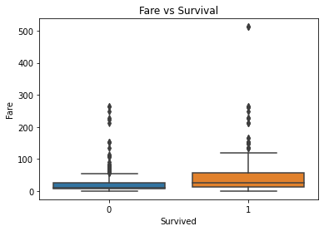
Observation
- Survivors generally paid higher fares.
- Many outliers exist in fare.

Scatterplot (Age vs Fare)

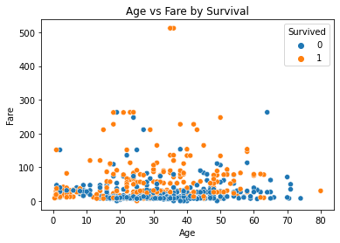
Observation
- Survivors are clustered at higher fares.
- Younger passengers show higher survival.

b) Visualization using sns.pairplot() and sns.heatmap()
